RazorHack 2024

Writeup

“Homer's Reminders 1”

Homer, one of RazorPower's nuclear technicians, is known to be quite forgetful. So, he likes to leave himself reminders of important things in files. Can you find the reminder Homer left himself? The flag's format should be flag{insert reminder here}.

Author: Kate

In this challenge, participants will work with a file named homers_reminder1.gif, which they need to download. Attempting to open the file normally will result in an error.

Here’s the error message a Mac user might see:

Here’s the error message a Window’s user might see:

Opening the image in a hex editor reveals some interesting details. Typically, the first few hex bytes indicate the file type, providing a signature unique to each format.

Referring to the provided hint, we see it suggests examining GIF file signatures. According to Wikipedia, a valid GIF file begins with one of these hex signatures:

47 49 46 38 37 61

47 49 46 38 39 61

To illustrate, let’s open a working GIF file displaying a "thank you" message (thanks for reading this write-up!).

In the hex editor, we see:

This working GIF matches the expected signature! Now, let’s look back at the original homers_reminder1.gif file. Notice that some of its hex bytes are reversed:

Instead of 47 49 46 38 39 61, we see 47 94 64 39 61.

By correcting these values to match a valid GIF signature, saving the file, and reopening it, we reveal the hidden message:

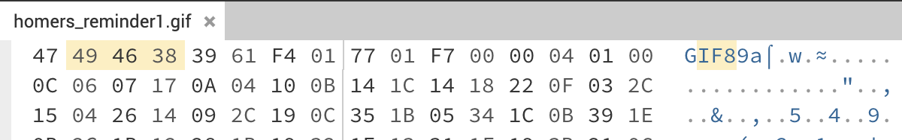

flag{Reminder: Do NOT leave your badge in the donut box.}